HELICOPTER MISSION REQUEST VADE MECUM
1st Edition, October 2016

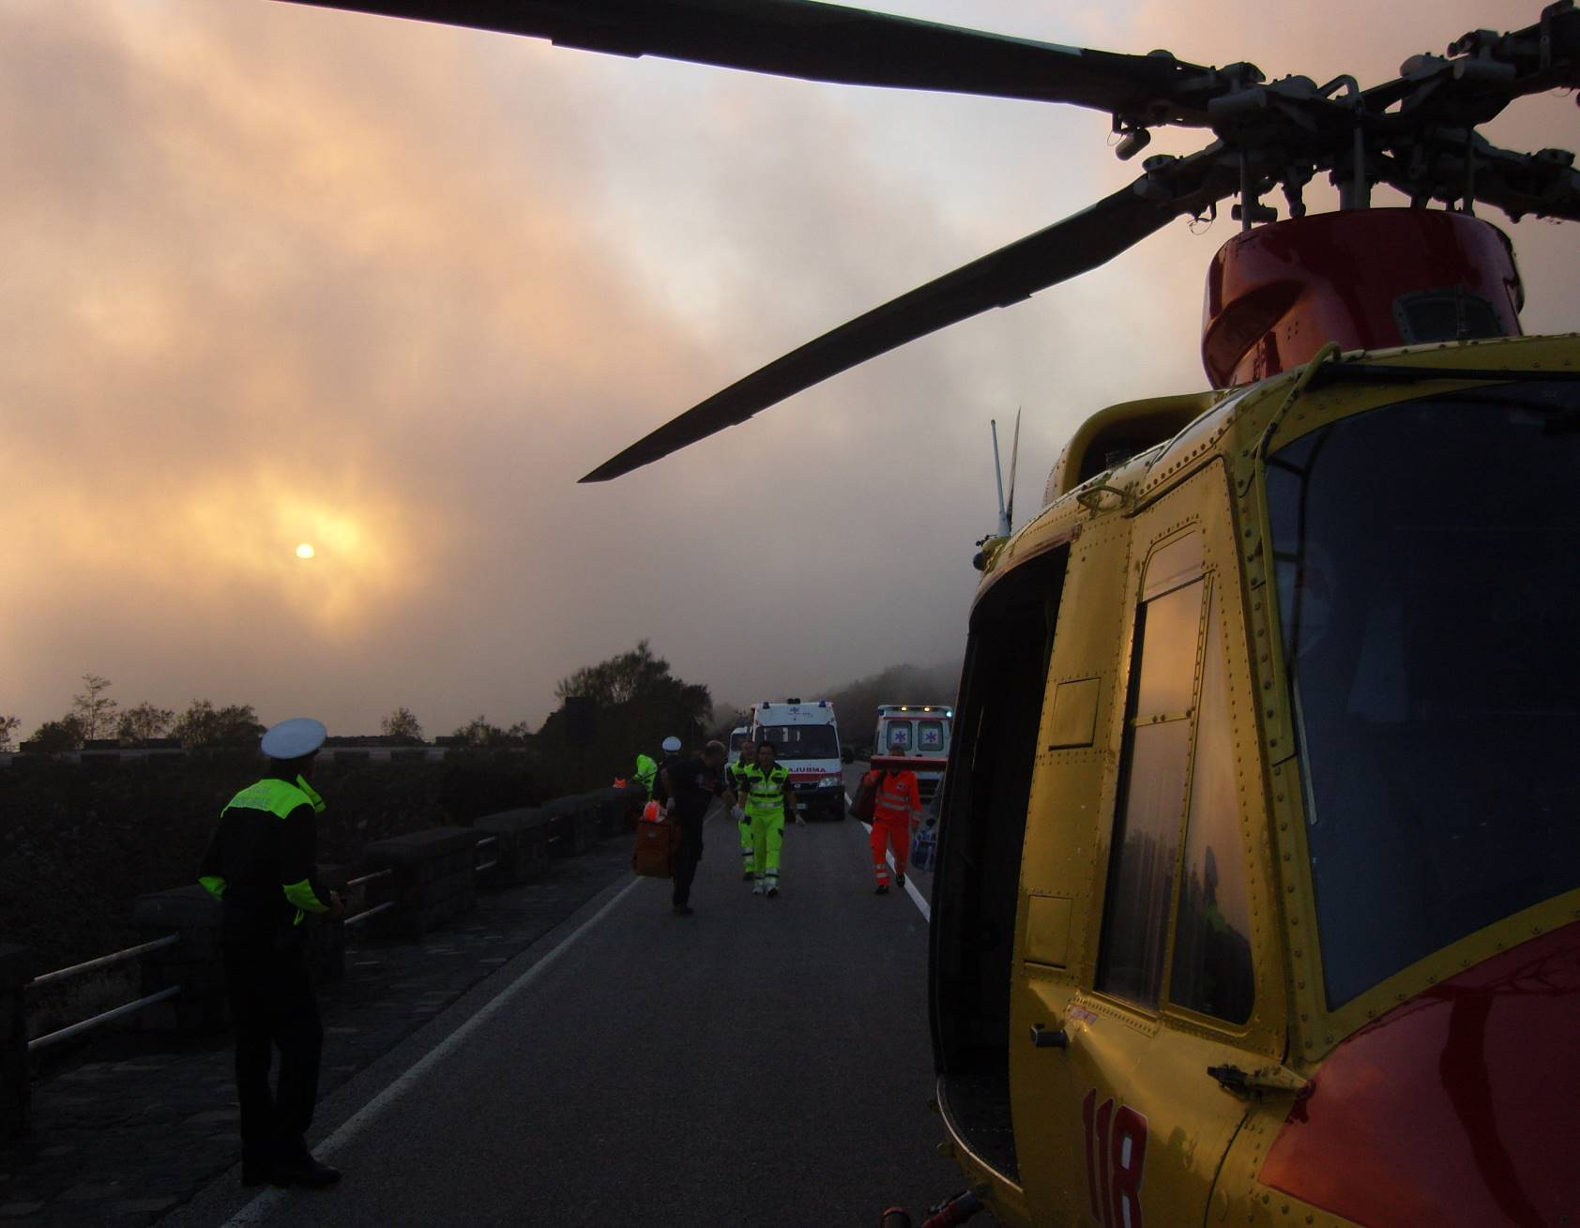

INDEX

1. INDEX 2
2. FOREWORD 3
3. DISCLAIMER 4
4. TYPICAL SCENARIO 5
5. DIFFERENT PERSPECTIVES 6
6. IDENTIFYING THE INTERVENTION AREA 9
7. ALTERNATE LANDING AREAS 12
8. HAVE A LOOK AT THE AREA 14
9. PREPARE THE LANDING AREA 17
10. SIGNALLING THE POSITION 22
11. RECEIVING THE HELICOPTER 25
12. HELICOPTER RUNNING ON GROUND 29
13. HELICOPTER STATIONARY ON GROUND 32
14. WHAT PILOTS SEE FROM THE AIR 33
15. THE R.O.M.A. CHECKLIST (next page) 37

FOREWORD
This document has been developed to help all those people, who may not be familiar with helicopters, to cope with a request for helicopter support (intervention) and with the preparation and management of the landing area.
Typical situations are:
- ambulance medical personnel in a road accident when requesting an emergency medical helicopter (HEMS);
- police personnel when requesting a police support helicopter;
- firefighters in a forest fire when coordinating operations with firefighting helicopters;
- support personnel when cooperating with a SAR (Search And Rescue) helicopter;
- Civil Protection personnel in an emergency context when in need of a rescue helicopter or an evacuation mission;
- civilian forces when dealing with a military helicopter intervention;
- etc.

The document is a helpful guidance for:
Front line (on-site) emergency personnel - They will understand:
- what are the hazards related to a helicopter intervention;
- what kind of information may be requested by the dispatch centre;
- what kind of information will be useful to the helicopter pilot;
- how to prepare the landing area;
- what are the signals to give to the landing helicopter.
Emergency dispatch centres personnel – They should be trained to:
- know what kind of information should be requested from front line personnel at the scene;
- know what kind of information will be useful for the pilots;
- give full support to the helicopter in order to find the area of intervention.
Pilots – They should know what kind of information will be available to them before and during the mission:
- where is the area of intervention;
- what to expect in the area;
- ground support for landing and subsequent take-off.

This document is a guideline for training personnel. They can amend it with the required information and disseminate it amongst the dispatch centres and the front line personnel (ambulance drivers, firefighters, police, etc.).
This tool is an initiative from Capt. Franco PESCALI, Italian Police helicopter group, and it has been further developed by the EHEST Specialist Team Ops & SMS.
This work is dedicated to departed Paolo PETTINAROLI, president of the "8 Ottobre 2001-per non dimenticare" (8 October 2001-not to forget) committee, in memory of the Linate air disaster.

Please support EHEST job by reporting your feedbacks and your suggestions to:
ehest@easa.europa.eu EHEST
stefano.burigana@gmail.com Specialist Team Ops & SMS, team leader

The EHEST Specialist Team Ops & SMS

DISCLAIMER
This document and the files related to the “Mission Request” tool have been developed by professionals with a wide experience in various types of operation and environments. The information suggested herein is a set of best practice behaviours to be explained to non-aeronautical front-line and on-site personnel that may cooperate with helicopters during some kind of emergency.
The trainer and the training organisation shall verify the information included and change it accordingly, in order to comply with national and local rules and Regulations.
EHEST and the Specialist Team Ops & SMS will not be responsible or liable, directly or indirectly, in any way for any misuse or for any law infringement subsequent to the application of these best practices.

TYPICAL SCENARIO
In order to understand the phases of an emergency helicopter mission, the following is a typical intervention request.

TRIGGERING EVENT
Something happens and an emergency arises. Generally, this involves human lives.
For example, a car accident with people in need of medical help.

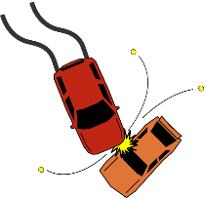

DISPATCH CENTRE INVOLVEMENT
Somebody alerts the emergency dispatch centre, in this example the medical emergency centre. It could be anybody: people involved in the accident, on-site ambulance, police, firefighters, nearby people, etc.

1

Information exchanged at this stage is extremely important. Based on this information, the dispatch centre can take the most appropriate action.

The dispatch centre will inquire about the on-site conditions and, if deemed appropriate, it will request the helicopter intervention.

If the on-site person who is calling has been trained, this information is passed in a very little time, thus reducing the time of intervention.
Moreover, if the on-site person is trained, the emergency centre will go very easily through the checklist to verify that the landing site is set up appropriately, avoiding long explanations and requests for further details.

HELICOPTER INVOLVEMENT
When assigning the mission to the helicopter, the dispatch centre will pass a certain amount of information to the pilot. This information is essential for:
- arriving in the intervention area;
- spotting the intervention site;
- landing safely;
- providing the most appropriate help.

2
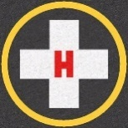
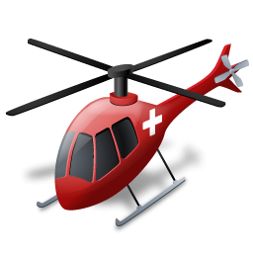

3

1

In order to have a fast, safe and efficient intervention of the helicopter, the on-site personnel and the dispatch centre must exchange crucial information, to be passed to the pilot, and then prepare the landing area.

This vade mecum explains what the on-site personnel should check, and what details the dispatch centre should gather in order to pass the most important information to the pilot.

DIFFERENT PERSPECTIVES
Things seen from the ground and from the air can differ significantly.
All the actors have their own perspective and report the situation based on this. Unfortunately, information passed in this way could be very confusing when elaborated from people using different references.

As an example, this could be the perspective of a person close to an accident:

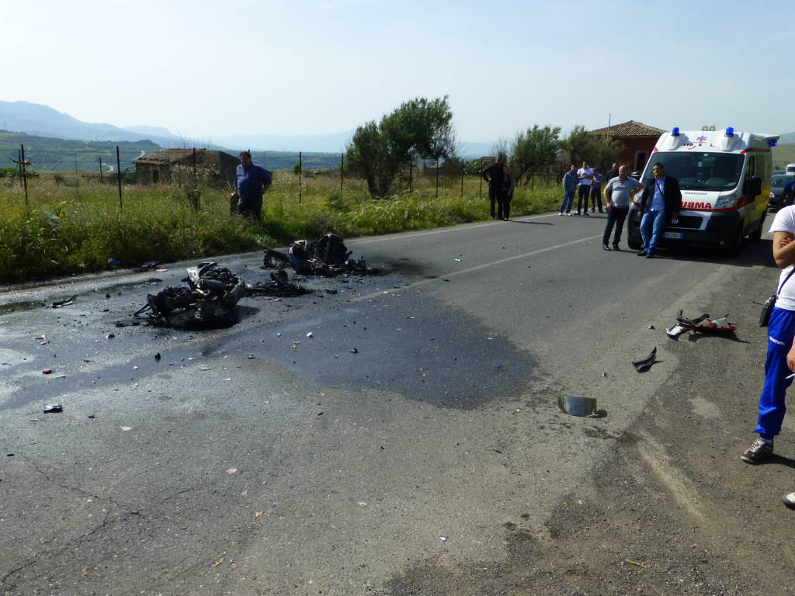
Picture 1 - The on-site personnel perspective

The on-site person reports to the emergency centre that an accident happened along the road from “Paternò” to “Adrano” (two local towns) at the intersection to “Adrano”.

Incidentally, there are two roads connecting the two towns: a main large uphill road and an old downhill country road. The accident happened in the secondary road, but no mention was made from the on-site personnel, considering the information they have provided clear enough and detailed. After all, “we are in a well open space… helicopter can see me from miles!”.

Because the main large road between the two towns has very heavy traffic and most accidents happen there, the emergency centre operator makes an erroneous assumption that this is the location of the accident and passes the information to the helicopter pilot accordingly.

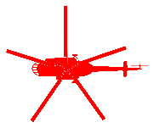
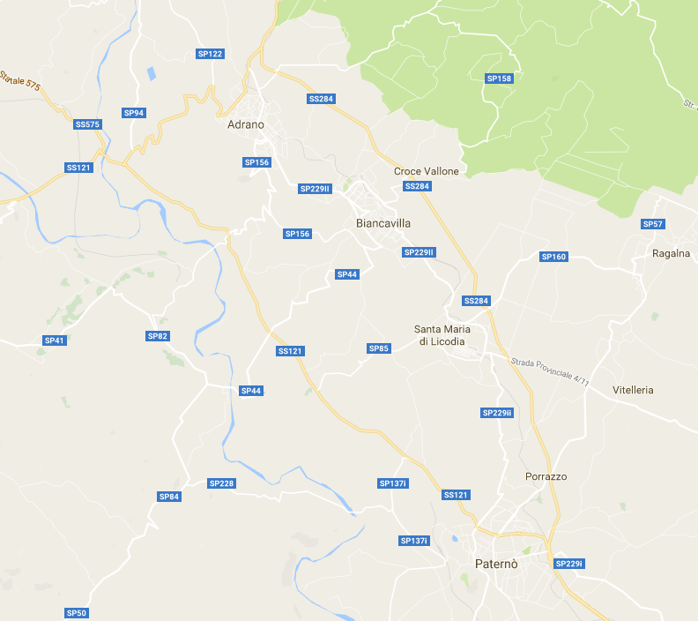
Main uphill road
Old secondary downhill road
Figure 1 - The emergency centre perspective

The pilot takes the information from the emergency centre and he makes up a mental representation of the area of operation, eventually plotting it on a roadmap. Once in flight what the pilot sees is a bunch of roads, houses, hills, trees, woods, rivers, ponds, moving and parked cars, and many other distracting elements. He has to spot some kind of clue among all these conflicting elements. If the initial information is not precise enough, it could be very difficult to catch the signs of the accident area.

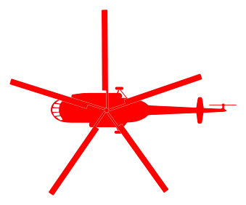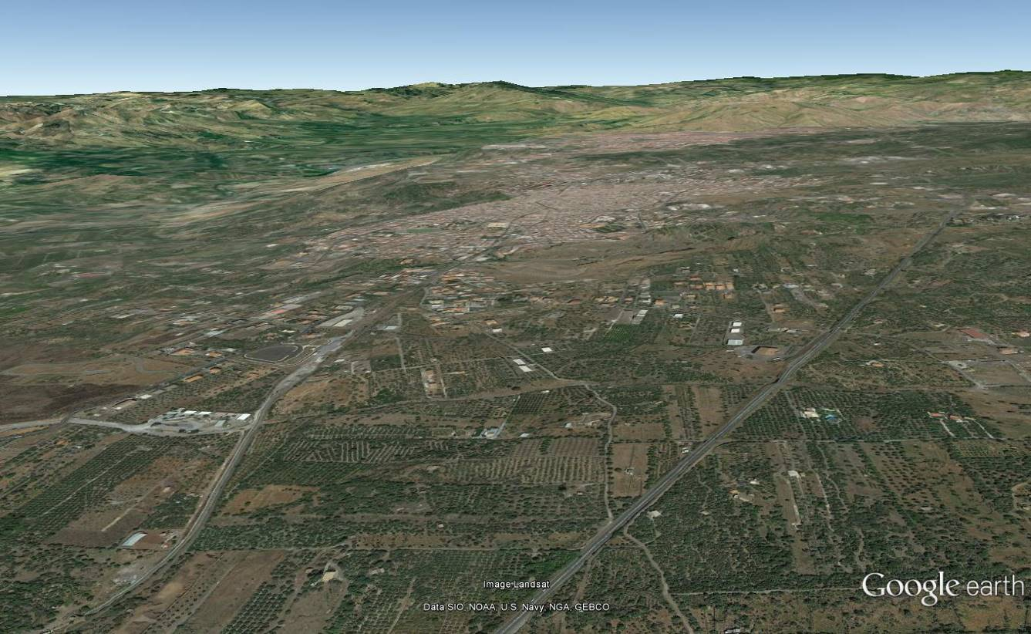
ADRANO
Main uphill road
Old secondary downhill road
Picture 2 - The pilot perspective

That’s why a well-trained on-site personnel and prepared dispatch centre operators are essential for an efficient use of the helicopter. Wrong or lack of simple information could deviate the pilot from reaching the right position.

IDENTIFYING THE INTERVENTION AREA
There is no practical use of information like “we are close to a high pine tree” while in the middle of a forest! Think wide!
When approaching the area, the pilot will initially face a wide space. The best clues he can spot are those horizontally large and vertically high, especially those in contrast with the surroundings. When passing the information to the emergency centre, try to explain the location of the emergency in these terms, which could be more useful references for the pilot.

GEOGRAPHICAL COORDINATES
This is, most of time, the best way to pass a position to the pilot. Helicopter navigation systems can easily accept geographical coordinates and can track the helicopter right over the emergency site, no matter the visual clues on the ground.
Nevertheless, locating and passing the correct coordinates is not always so simple, and common reading errors can bring the helicopter to a point only a few kilometres away from the target, but enough to make the operation more complicated to achieve.
Nowadays, most cellular phones have GPS capabilities. If available, it is suggested to retrieve the coordinates and pass them to the emergency centre. It is very important that the coordinates are passed exactly as shown in the GPS apparatus, reading every single symbol (° degrees, ‘ minutes, “ seconds) and dots/commas in the exact order.
Coordinates can be represented in several different ways and every GPS could show them differently. The coordinates of this accident site can be showed as:

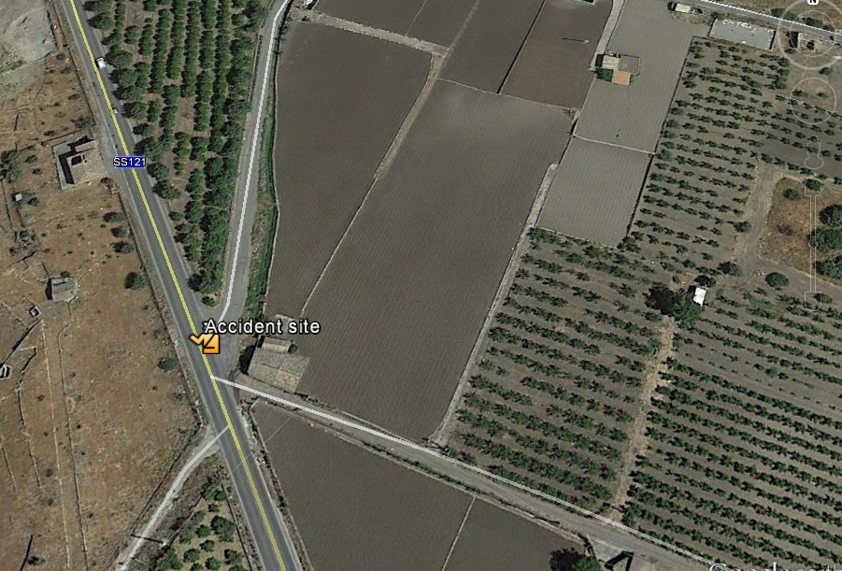
Degrees, minutes, seconds:
37° 37' 47.20" N
14° 49' 54.86" E

Degrees, decimal minutes:
37° 37.787' N
14° 49.914' E

Decimal degrees:
37.629778° N
14.831906° E

Picture 3 - The same place can be indicated in different ways of representing the same co-ordinates

If misread, the coordinates can indicate wrong geographical positions and they can be several kilometres away from the target.
In the following example, the digits read from the GPS are the same, but symbols and dots have been wrongly placed, producing substantially different positions on earth.

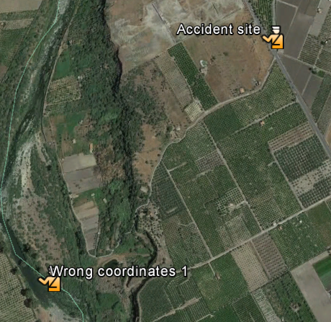
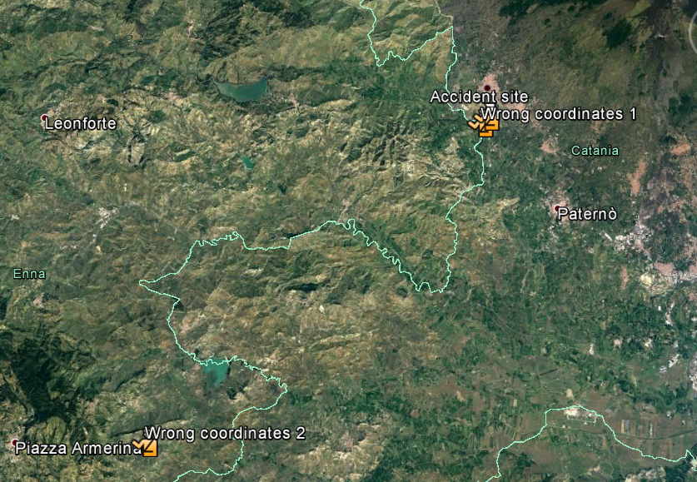
1 Km
40 Km
Accident site:
37° 37' 47.20" N
14° 49' 54.86" E

Wrong coordinates 1:
37° 37.4720’ N
14° 49.5486’ E

Wrong coordinates 2:
37.374720° N
14.495486° E

Picture 4 - The same GPS digits separated in a wrong way can point to different places

SOCIAL MEDIA
Social media like WhatsApp can easily send the position to other people. The information can then be seen in street and satellite maps directly from the phone or the computer.

CITIES/TOWNS
Major towns are generally easily identifiable by the pilot, both on charts and from the air. Do not assume, however, that small villages are known with certainty by the pilot or available on the on-board maps. Refer first to a major town in the area and then eventually specify the small village, indicating also its position in relation to the town (north of the town, along the road from town A to town B, etc.).

ROADS
The reference number of the road is a valid indication, especially with highways and important roads. However, small country roads could be confused from the air, especially if close to each other.
The pilot will likely “follow” the road until he sees the intervention area; but, it is always good practice to indicate a more precise place along the road if at all possible.

RIVERS
Rivers are also very useful reference indication. Be aware that a small creek fully covered by vegetation, where the water cannot be seen from the air, could be not so spottable.

BRIDGES
Above the terrain bridges are well identifiable. Terrain level bridges, underpasses and tunnels may not be so identifiable.

HIGH VOLTAGE POWER LINES
High voltage power lines can be easily seen from the air. There could be more than one power line crossing the area, so additional information could be useful (e.g. running North-South, crossing the valley, etc.).

FLAT WIDE LANDMARKS
Characteristic flat areas may be easily spotted from the air. These could be manmade or natural landmarks; like football fields, graveyards, lakes, city parks, racetracks, etc.

VERTICAL LANDMARKS
Vertical elements should extend well above the surroundings. For example, churches, towers, skyscrapers, isolate peaks, etc.

ALTERNATE LANDING AREAS
Sometimes the place where the emergency takes place is not suitable for the landing of a helicopter or it could be not safe (industrial fire, dangerous vapours, bad meteorological conditions, etc.). Some other times there is already a place assigned as a helicopter landing place (hospital landing site, civilian heliports, military training sites, etc.). A nearby alternate landing place could be feasible or even suggested. Big flat fields, football stadium, empty car parking areas, etc., can result in a more suitable place or it can eventually allow more than one helicopter. Often these places are closed areas, so population is not allowed, resulting in a much safer helicopter operation.

SPORTS FIELDS OR CLOSED FIELDS
These are ideal and safe places for a rendezvous with a helicopter. Generally, these places have previously been selected by the municipal authorities for the landing and take-off of emergency helicopters.
Care must be taken in order to verify that the guardian is advised and able to open the access in time. Moreover, provisions must be sought in order to clear the area of possible athletes, workers or people inside the facility.
In case of night operations, the lights must be switched on well before the arrival of the helicopter, because they generally take some time to heat up before illuminating.

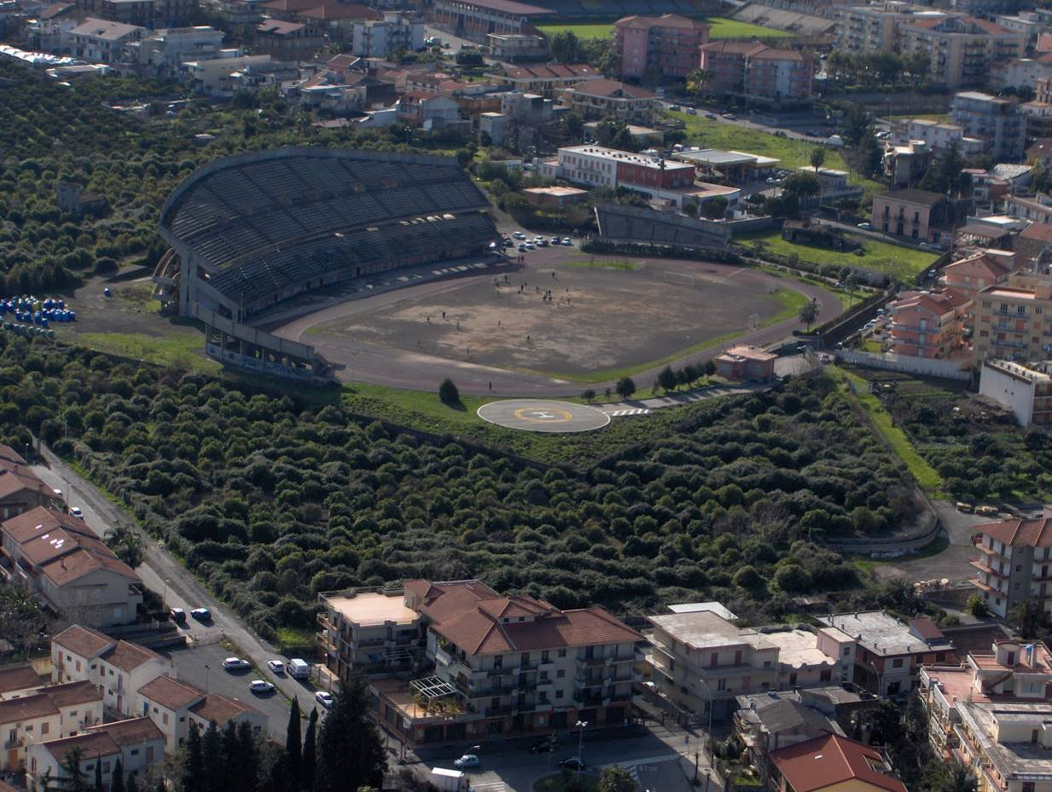
Picture 5 - Sports fields are often used as pre-planned landing site

SUITABILITY OF AN ALTERNATE LANDING AREA
Besides verifying the suitability of the alternate landing area for the operations with a helicopter or helicopters, it must be verified that the emergency vehicles can approach and enter that area. Things to be checked might be:
- Are the connecting roads suitable for the emergency vehicles (off-road, holes, mud, bridges, etc.)?
- Is the entrance large enough for the emergency vehicles?
- Is there enough space for manoeuvring the vehicles?
- In case of helicopter accident, can firefighters and ambulances reach the landing area?

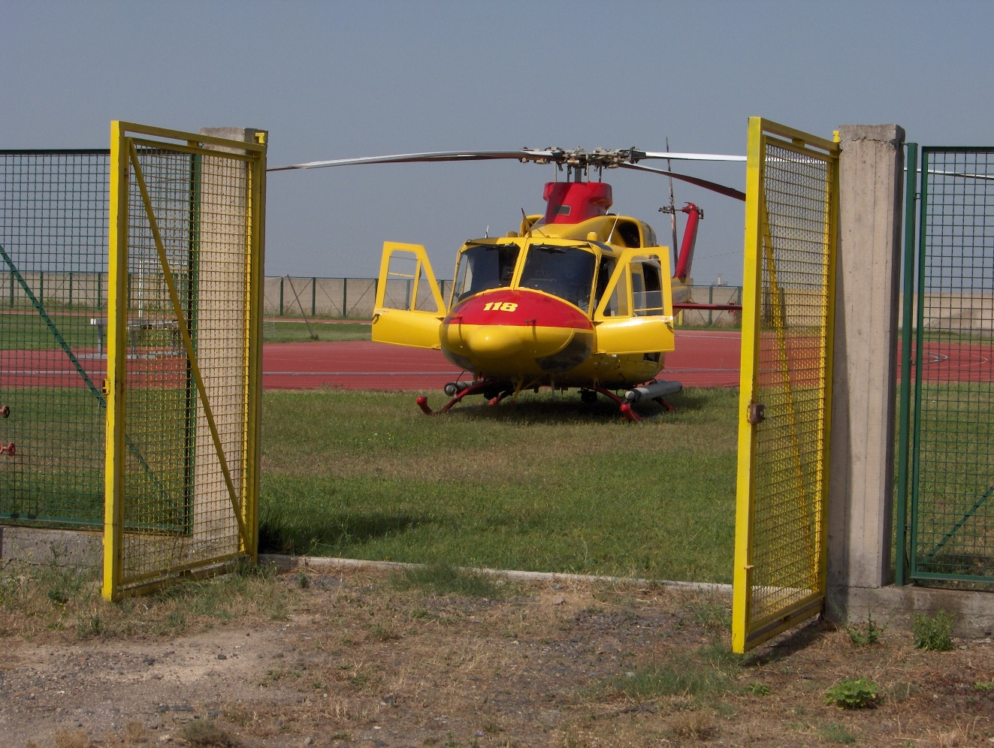
Picture 6 - Always verify the accessibility of the area by emergency vehicles

HAVE A LOOK AT THE AREA
On-site personnel are the eyes of the pilot, and they should report what they see in the area in order to prepare the pilot for the landing. The pilots verify several elements before executing an approach to land in an unknown site. Some of these can be anticipated by the personnel.

LANDING SPACE
The suitability of a landing site will be ultimately decided by the pilot when reaching the area. A flat, obstacle free, 25 x 25 meters open area is generally a good place to land. Some helicopters need up to a 50 x 50 meters clear area. If you spot a nearby area with these characteristics, report it to the emergency centre and prepare it for the landing.
If such an area is not available nearby, the pilot can elect to land in a much smaller place. It is suggested to prepare the most suitable space available, but be prepared to support the helicopter landing in a different area.

OBSTACLES
Everything loose or coming out from the ground could be an obstacle. The landing area should be free of any object protruding more than 20/30 cm from the ground. When selecting the most suitable area, consider not only the body of the helicopter but also its rotor: they have diameters from 12 to 16 meters. Bushes, fences, rocks, guardrails, road signs, etc. could be dangerous if inside the rotor area, even if they seem to be low enough.

POWER LINES
Verify the presence of any power lines, telephone lines, cableway or any lines in the vicinity. These are sometimes difficult to see from the air and are extremely dangerous. Inform the emergency centre if you see some.

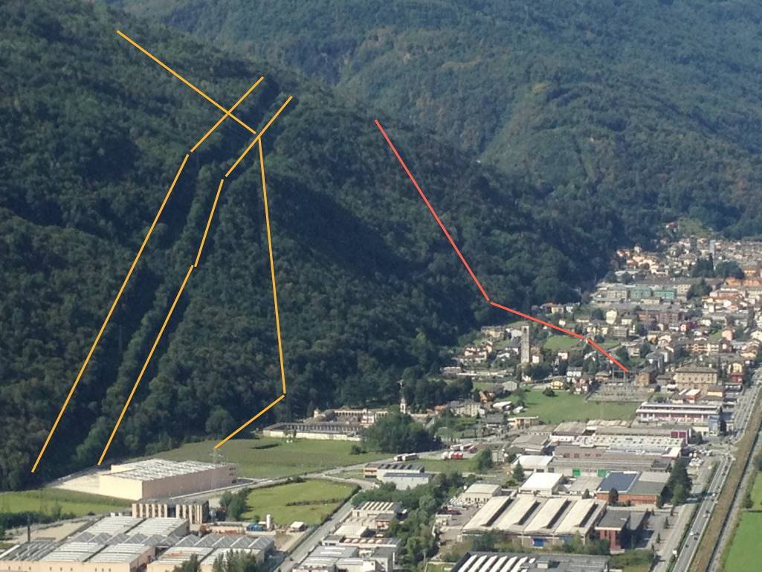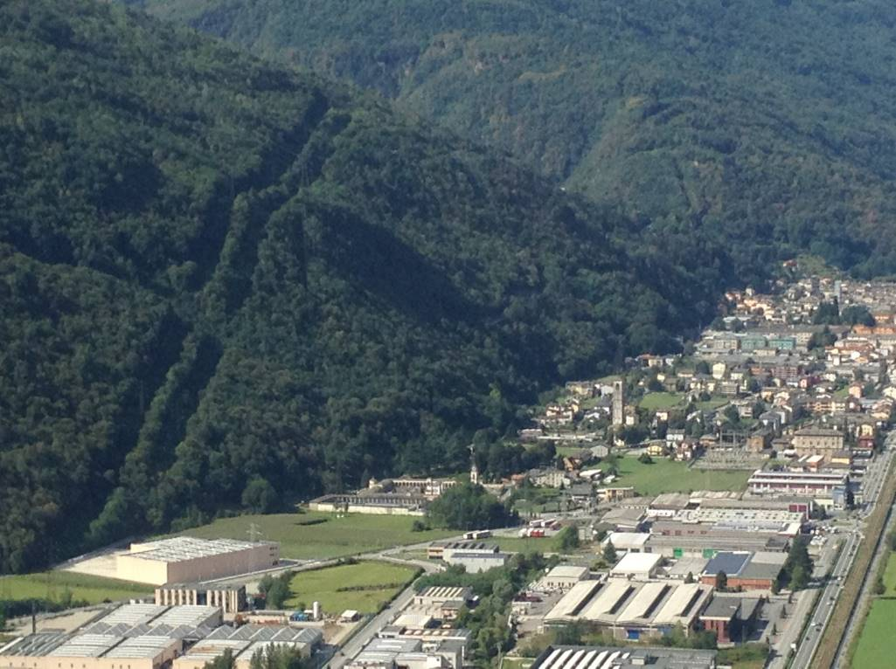

Picture 7 - Not all power lines are easily visible from the air

VISIBILITY
The visibility in the area could be very different from where the helicopter takes off. Based on the visibility the pilot will select the most appropriate speed, altitude and track to reach the emergency area, or he could even cancel the mission.
Use your best judgment to report the horizontal visibility, e.g. along the road. A good estimate to be reported could be:
  - Below 1 km
  - Between 1 and 3 km
  - Around 5 km
  - 10 or more km
Report if you see fog, smoke, or any other thing that could reduce the visibility in the surrounding area.

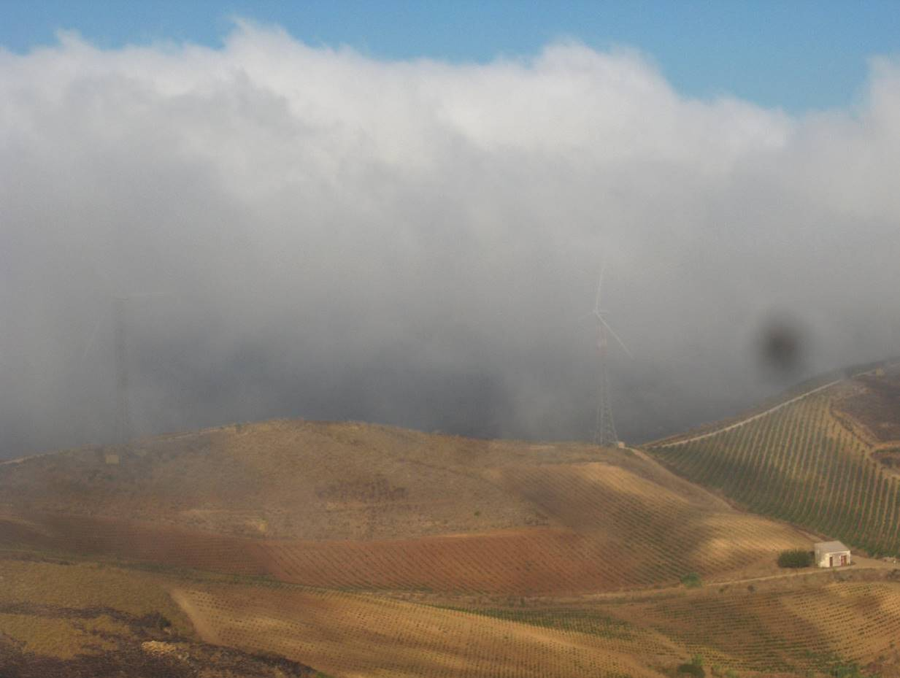
Picture 8 - Visibility and clouds can be very different from place to place

CLOUDS
The two critical pieces of information for the pilot about clouds are:
  - The height of the lower clouds
  - The percentage of the sky covered by those clouds

The height of the clouds is not easy to estimate. Following are some possible reference points that could be reported to the emergency centre.
  - The clouds are just above the houses, trees, buildings
  - I can definitely see the clouds moving above my head
  - I can see the clouds below/touching/just above the mountain/hill peaks
  - The clouds are well above the area/mountains

Cloud coverage can be reported as “how well I can see the sky through the clouds”:
  - I cannot see the sky
  - I can barely see the sky
  - There are several holes where I can see the sky
  - The sky can be seen quite well

WIND
The pilot has generally several ways to estimate the wind while flying to the emergency area. There is no real need for the on-site personnel to estimate the wind, but understanding where it comes from will be useful when giving indications to the landing helicopter.
Wind information should be reported to the emergency centre if there is a strong or very variable wind in the area.

PREPARE THE LANDING AREA
If a suitable landing area has been spotted, this should be prepared for the safety of the helicopter, the people in the area and the properties.

PERSONS
Persons should stay at least 50 meters away from the landing place. The incoming helicopter will produce a strong wind that could be dangerous.

CARS, MOTORBIKE
The wind produced by the helicopter could raise small debris from the ground which can be thrown against the vehicles and motorbikes parked near the area. In particular, the motorbikes could be blown over due to the wind.
Move the vehicles and motorbikes away from the landing area. Close all the windows and doors.

ROADS, HIGHWAYS
If the landing is very close to, or on a road, stop the traffic in both directions.
If the helicopter will land on a highway, have the police to stop the traffic in both directions. In some countries it is mandatory.

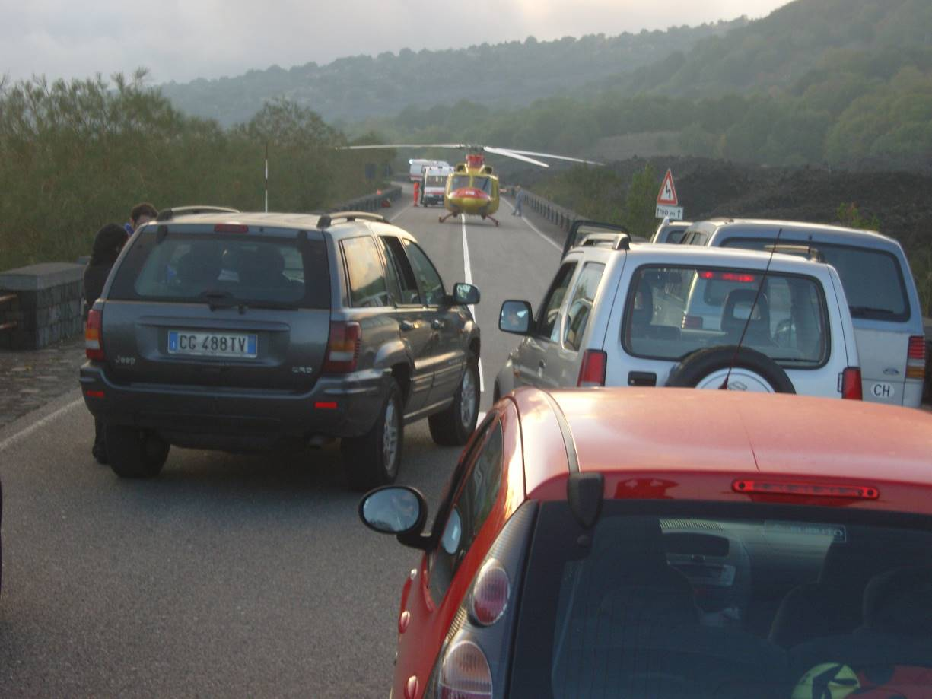
Picture 9 - Stop the traffic in both directions

Do not use traffic cones. These will be blown away by the rotor downwash.

DIRT, PAPER, GARBAGE
Everything small and light will be raised, blown away or sucked into the helicopter rotor. Try to free the area from this kind of loose objects.
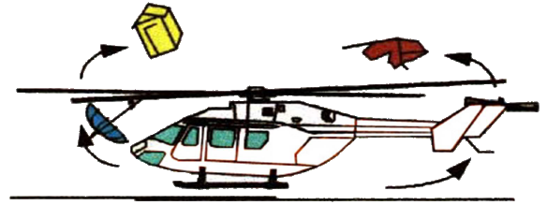
Figure 2 - Rotor downwash can rise several loose material

DUST, SOIL, SAND
Landing sites could be covered with light dust (like volcanic areas), sand (e.g. along beaches), or snow. This kind of material, when ingested by the helicopter rotor downwash, can be raised from ground in a thick brown/black/white cloud which could impair the pilot’s sight. When possible (e.g. in football stadium, industry fields, etc.) the ground should be watered to the maximum practicable extent.

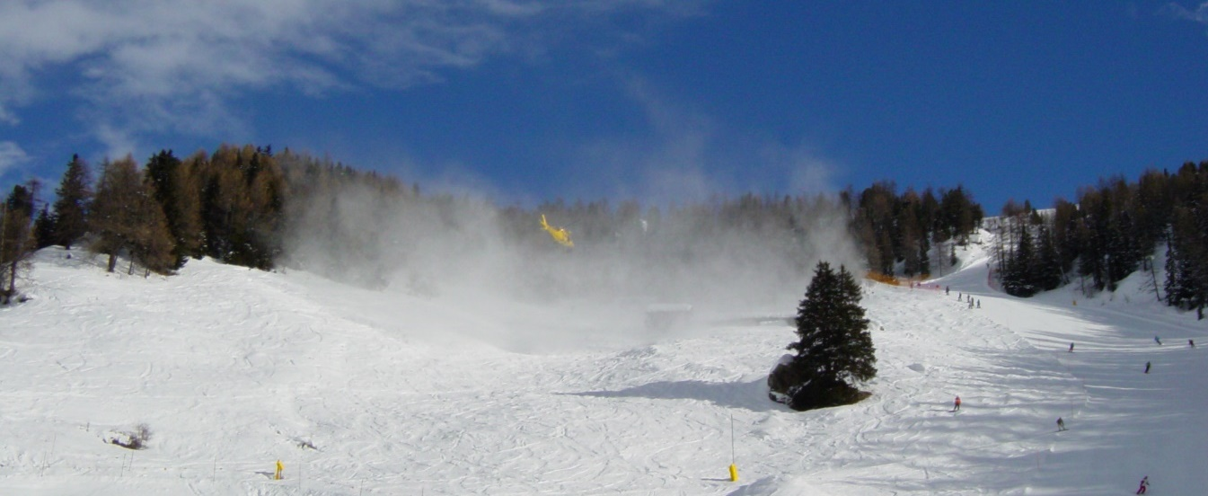
Picture 10 - Fresh snow can reduce the pilot's sight

If you are giving indications to the landing helicopter over a snowed surface, lean down with one knee on the ground and keep still, protecting your eyes. You could become the only visible reference for the landing pilot.

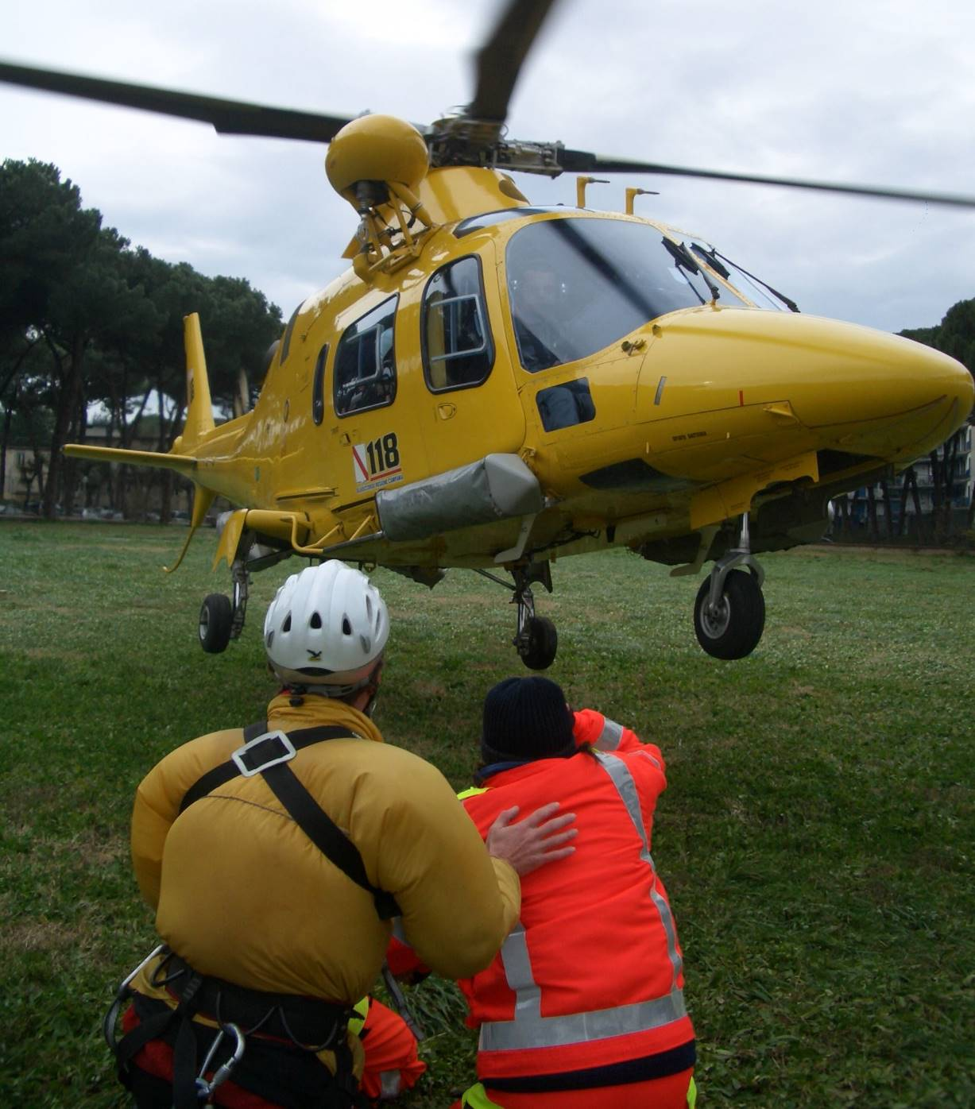
Picture 11 - Place yourself on one knee

TENTS, UMBRELLAS, TARPAULINS
Large and light objects can dangerously fly away or they can be sucked in by the helicopter rotors. These objects shall be secured or removed from the area.

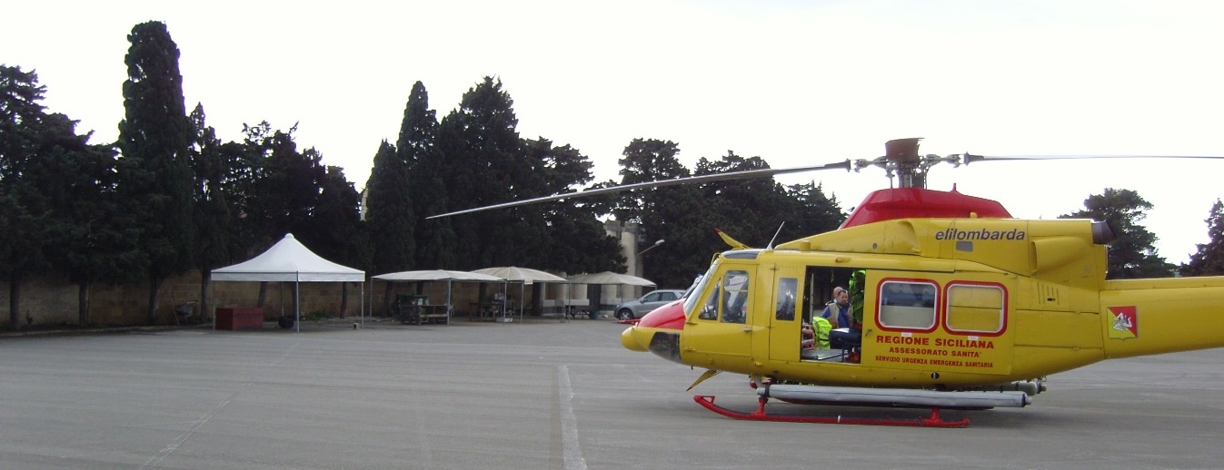
Picture 12 - Verify and report the presence of tents or tarpaulins that cannot be removed

ANIMALS
Pets, cattle and wild animals are very unpredictable. With the loud noise they could run toward the helicopter or nearby persons.
Try to ward off the animals as much as possible or constrain them in closed areas.

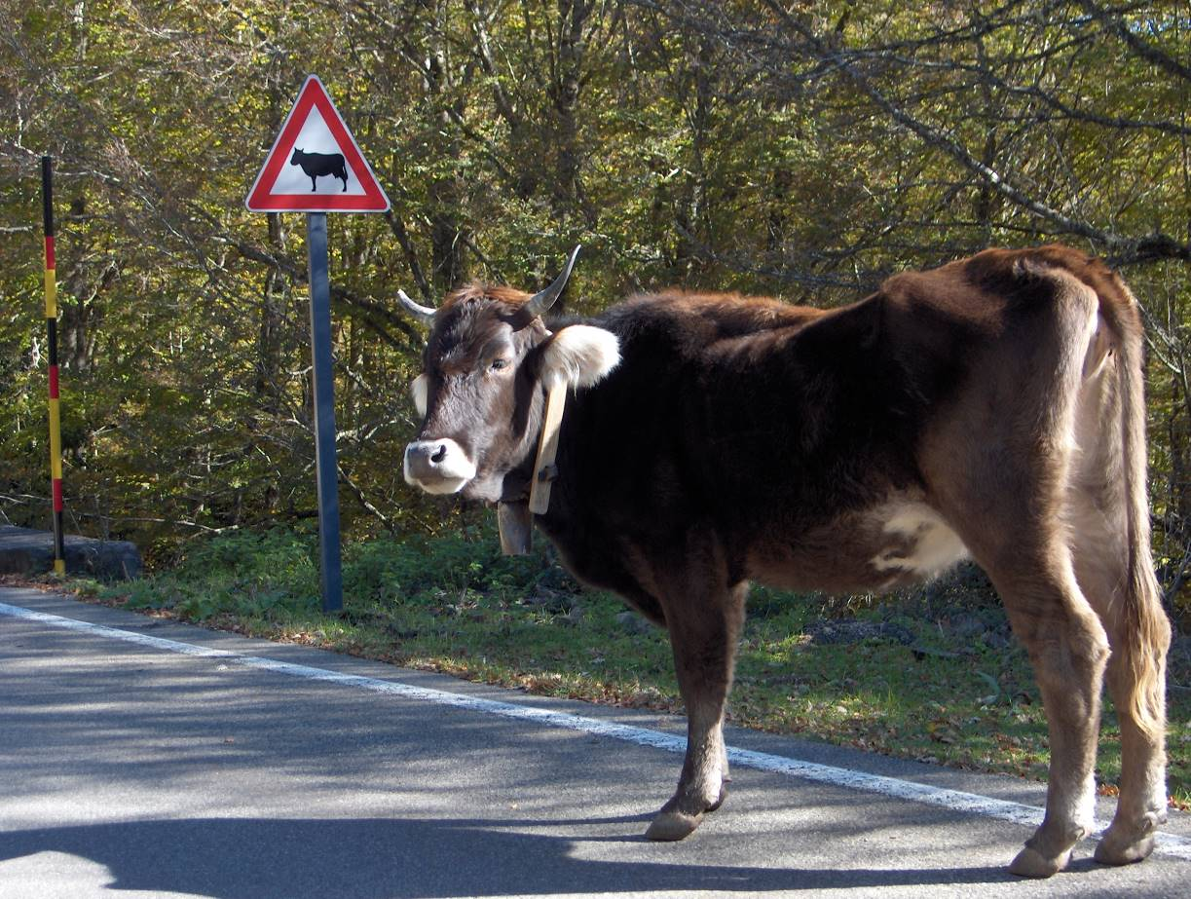
Picture 13 - Ward off wild animals

NIGHT OPERATIONS
In case of night operations outside a dedicated illuminated helipad, the landing site should be illuminated. Use available lights to illuminate the landing site, like cars or spotlights.
All the lights should be pointed down into the ground. Avoid using cars’ main-beam headlamps. Dipped-beam headlamps and fog lights are ok.
Never point lights directly toward the helicopter or the pilot. Never point laser beams toward the pilot.
Some lamps, like sodium-vapour lamps, used in sports fields or for urban illumination, can take up to 15 minutes before reaching full illuminating power. In this case switch the illumination system well ahead of time.

SIGNALLING THE POSITION
Do not assume that the pilot knows exactly where the intervention area is. He is looking for clues on the ground.
There are some things that the on-site personnel can do to make the area more visible from the air.

FLASHING LIGHTS
Emergency flashing lights, for example those on police cars or ambulances, are very visible at night. During the day, they are not so visible from distance though, but they can dispel any doubt about the area of intervention.
Be aware that when operating in a wooded place, or near building sites, roofs, galleries, or close to high surroundings like trees, walls, houses, etc., the personnel and the emergency vehicles (flashing lights included) could become almost invisible from the air, even if overflown by the helicopter.

SMOKE
During the day, the presence of a thick smoke could be very visible from a long distance. Generally, smoke signals can be found in specialist safety stores. Police cars and ambulances are very often supplied with such items.
Advise the emergency centre if deploying a smoke signal or if there is any smoke nearby the area. In this way the pilot will know what to look for.

Picture 14 - Smoke may be seen from very far away (20 NM in this picture)

FLARES, FIRES
NOTE – Try avoid using these to signal your position: open flames and flares could be dangerous to nearby personnel and to the helicopter. Give proper consideration that fire could be spread around by the rotor downwash.

During the night smoke cannot be seen, but fires or flares are clearly visible.
Flares last from seconds to some minutes, so the helicopter should be already in the area before using them. Be sure to see or hear the helicopter before deploying any flare.
Advise the emergency centre if you are going to deploy any flare or if there are fires in the area, so the pilot can look for them.
Do not use flares, flames or other inflammable devices in presence of fuel, gasses or any flammable substances.
Handheld flares, with no material fired away, are preferable. Always point flares away from the helicopter.

HAND HELD (preferable) | PROJECTILE PYROTECHNICS  (try to avoid)
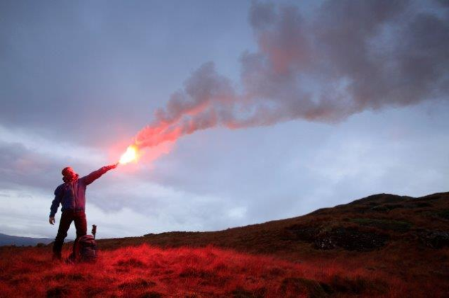 | 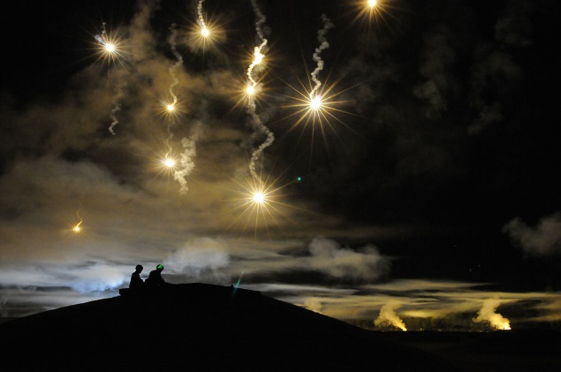

RADIO COMMUNICATIONS, CELLULAR PHONES
Almost all emergency vehicles have radios to communicate with their own dispatch centres (police, firefighters, ambulances, etc.). Unfortunately, they generally work on different bandwidths and will or will not make use of radio bridges. Some helicopters are equipped with multi-band radios and are able to switch between bandwidths.
Some helicopters also have the possibility to communicate by phone while in flight.
When contacting the emergency centre, report if there is any monitored radio available, the frequency/channel used and the related bandwidth/network (police, firefighter, medical, etc., network). Expect a radio call from the helicopter.
Also provide one or even better two contact mobile phone numbers. If needed, the emergency centre or the pilot will call in order to have more precise information.

PASSING INFORMATION TO THE HELICOPTER
If in contact with the helicopter, the pilot could ask some specific questions to better spot the area of intervention. Most of time the helicopter is already nearby and can be seen from the on-site personnel. In this case, if in contact with the pilot or with the emergency centre, you can direct the pilot using the “clock position”. This is the relative direction of the helicopter described using the analogy of a 12-hour clock to describe angles and directions. Imagine a clock face lying flat in front of the helicopter, and identify the twelve hour markings with the directions in which it points. Refer always to the nose of the helicopter, not to yourself on the ground.

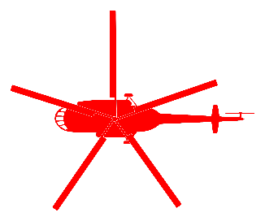
“We are at your 10 o’clock”
Figure 3 - The "clock position"

RECEIVING THE HELICOPTER
The landing to an unprepared site could be the most dangerous part of a helicopter mission. There are several risk factors that can be hazardous for human life, for the nearby properties and for the helicopter itself, like:
- Persons, curious bystanders and people involved in the emergency
- Rescue/emergency personnel
- Animals
- Vehicles
- Dust, sand, water, snow, debris, little stones, flying objects, umbrellas, sheets, etc.
- Power and telephone lines
- Obstacles on the ground
- Strong wind, gusting wind or even no wind at all (increased need of power)
- Glare from the sun or from torchlights at night
- Slope or irregular surface
- Dangerous substances (inflammable, chemical, toxic, etc.)
- Etc.

The on-site personnel reduce some or most of these risk factors significantly by being prepared and applying all the appropriate safety measures.

INDICATING THE LANDING SITE
In the aeronautical world there are several body and hand signals designed to communicate with the pilot. On-site personnel do not need to know all those signals, but it would be very useful to use a couple of them.
When flying low, searching for the intervention area, sometimes people on the ground waves off the helicopter just to say hello. This could be very confusing for the pilot who could not understand if that person is requesting help or just having fun. Internationally there are two well defined body position to request help or to refuse it:

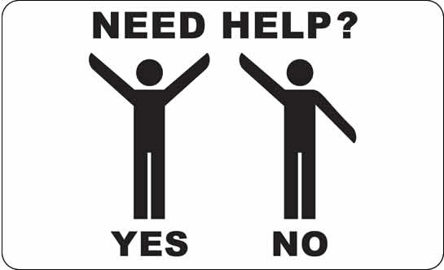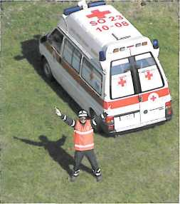
Picture 15 - The signal for the landing position

When the helicopter is reaching the site, place yourself still, with both arms up, at the edge of the landing site (remember to step away when the helicopter is landing) with your back into the wind. This simple signal will communicate to the pilot that:
  - I need help
  - This is the place where we were waiting for the helicopter
  - I recognised this as a suitable place to land
  - I prepared the landing site with the common safety rules
  - The landing site is ready for your landing
  - If you approach the site facing me, you will have a head wind

The wind is an important factor for the pilot and the indication about the wind direction on the ground will help him to choose the best direction for the landing.
Place yourself with the wind coming from your back, so the pilot will approach in front of you and he will have a head wind approach.
If in doubt where the wind is coming from, place yourself in the middle of the landing site and throw some grass or some light soil into the air. Falling down, it will move with the wind.
Expect a possible landing not into the wind. The pilot will take into consideration several other factors for the best approach. However, having your clear indication of the wind on the ground, the pilot will be able to assess the wind better during the landing.
Be prepared to step away when the helicopter is landing and protect yourself from the rotor downwash.

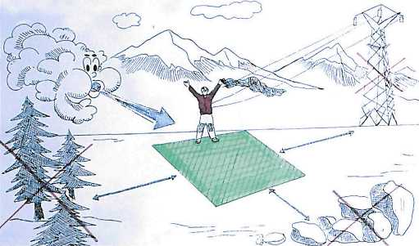
Figure 4 - Indicating the landing site

PROTECT YOURSELF
Use personal protective equipment whenever possible. The helicopter moves objects and makes a lot of noise.

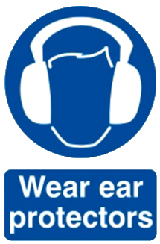
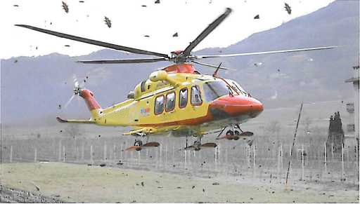
Picture 16 - Use protective equipment whenever possible

MIND YOUR HAT!
Do not wear any ball cap, military or service cap, or any hat at all: they will very probably fly away with the rotor downwash.

WINCH OPERATIONS
Many emergency helicopters are fitted with a winch that can lower and rescue personnel while in a hover. The free space needed on the ground will be much less than the one needed for landing.
If you see that the helicopter is hovering above you and starts winching personnel, you should:
  - Keep your position
  - Do not try to grab or touch the winched person or the winch itself, especially if they have not touched the ground yet. Helicopters can build up a certain amount of static electricity during the flight that will be discharged the first time the winch touches the ground.
  - Protect yourself and people nearby. Hovering helicopters can produce strong downwash winds. They will eventually pick up light objects from the ground (leaves, sand, etc.) and can also detach some branches from the trees underneath the rotors.
  - If in a sloped surface, hold yourself on a steady thing (rocks, trees, etc.).
  - Let winched personnel come to you and follow their instructions.

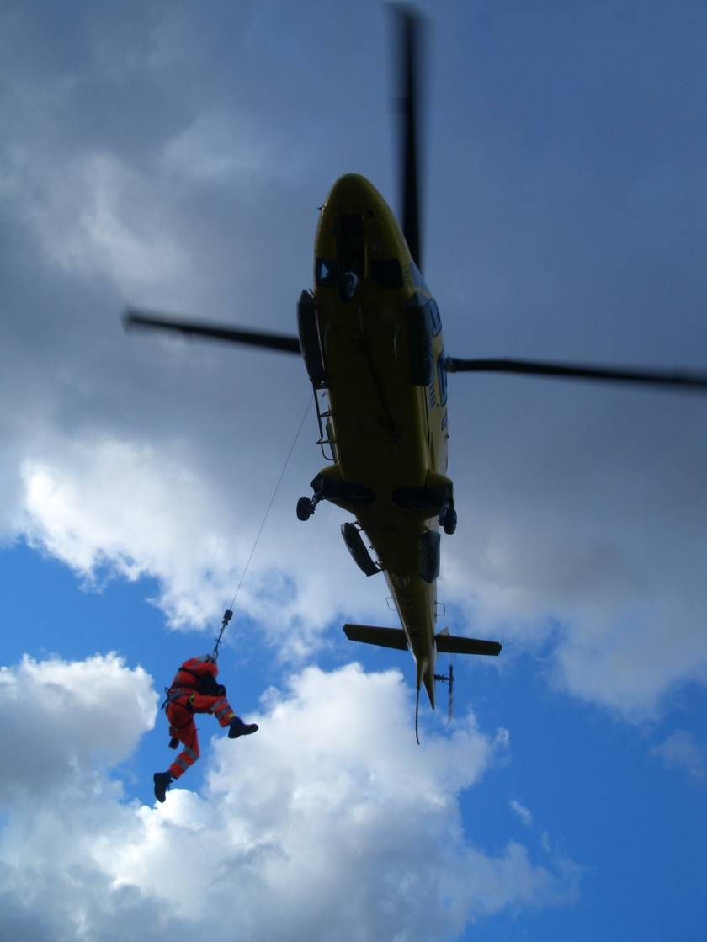
Picture 17 - In case of winch operations, let the emergency personnel come to you, or follow their instructions

HELICOPTER RUNNING ON GROUND
Once on ground the helicopter could be kept running or the pilot could shut off the engines. When the rotors are turning, the helicopter is very dangerous and nobody shall approach the helicopter unless escorted by the crew.
There are several hazards working around a helicopter:
- Main rotor – The tips of the main rotor are very flexible and, in combination with gusting winds, flight control position and slope of ground can become very low to the ground, especially in the front part of the helicopter. In many cases the turning rotor tips can lower down to a man’s head height.
- Tail rotor – At the back of the helicopter, it turns much faster than the main rotor. Due to its fast rotation and because people walking tend to look down, the tail rotor becomes invisible and very dangerous.
- Engines – Engines’ air intakes suck a great amount of air and light objects can be ingested by the engines. Exhaust ducts eject very hot gases in the back of the engines.
- Noise – Engines and rotors produce a quite loud noise. Protect your ears whenever possible.
- Moving air – Even if the helicopter is not in flight, the turning rotors produce some moving air around the helicopter which can still move light objects.

NOTE – Following is important safety information on how to work around a helicopter. The front-line and on-site personnel shall be familiar with and apply this information.
Even if familiar with helicopters, do not consider yourself authorised to approach and work within the helicopter area, even when the rotor is stopped: ALWAYS EXPECT AND FOLLOW THE CREW INSTRUCTIONS.

JUST WALK!
Around the helicopter, either with rotors running or still, never run, jump or rush! Keep calm. Do things quickly if necessary, but always be in control of your movements and actions. Erratic movements can hurt or be dangerous.

APPROACHING OR LEAVING THE HELICOPTER
Always enter or exit the helicopter and the disk rotor under the forward area of the disc. A 45° path from the nose is preferred.
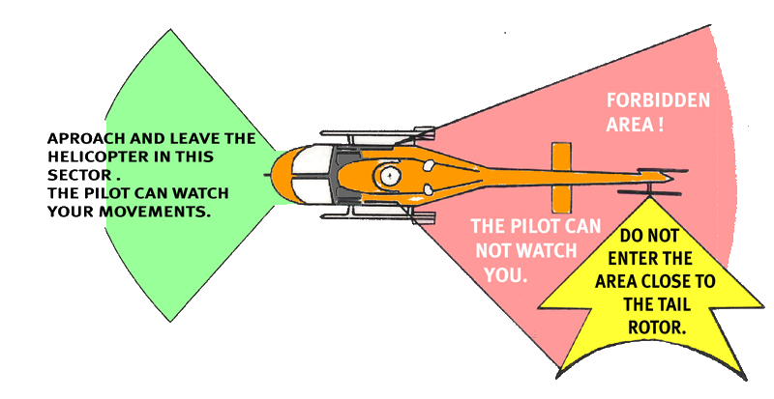
Always look at the pilot before moving in or out. Some organisations require that moving people indicate the intention to the pilot (e.g. by indicating where he intends to move) and waiting a thumbs up from him before moving.

No matter how big is the helicopter, get used to lower your head every time you get in or out from the helicopter.
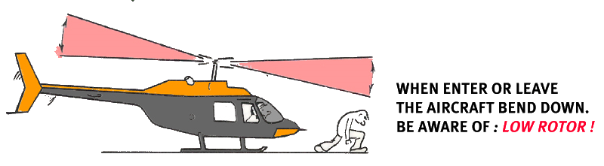
During engine start up or shut down the rotor will further lower due to a lack of centrifugal force. It is forbidden to enter or exit the helicopter until the rotor is completely stopped or fully running.

The back of the helicopter is completely forbidden to everybody. The tail rotor is extremely dangerous.
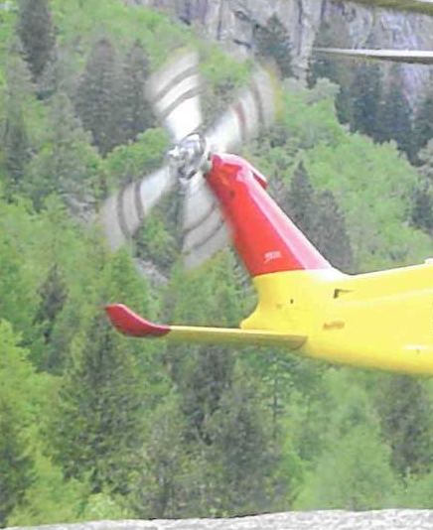
Picture 18 - The tail rotor can be invisible

Always enter and exit downhill.
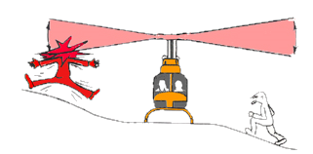
APPROACH AND LEAVE THE AIRCRAFT AT THE LOWEST POINT OF THE TERRAIN

Keep everything below your head.
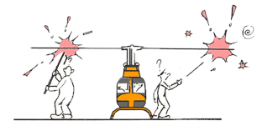
WHEN LOADING OR UNLOADING THE AIRCRAFT, DO NOT THROW OBJECTS CLOSE TO THE HELICOPTER
LONG OBJECTS, LIKE SKIS OR BACKBOARDS, MUST BE CARRIED HORIZONTALLY

HELICOPTER STATIONARY ON GROUND
With rotors stopped, the helicopter could be dangerous to people not used to dealing with such a complicated machine. Many persons hurt themselves or damage the helicopter just moving around it.
Avoid passing to the back of the helicopter. If walking from one side to the other, prefer passing in front of the helicopter instead, even if it will be a longer distance.
Never pass under the tail boom.
When walking around the helicopter, stay well clear of the structure. There could be several protruding sensors or parts that can be damaged.
All vehicles must stay outside the rotor disc, and they shall approach the helicopter slowly.
All the persons not strictly involved in the loading/unloading the helicopter must stay away from it.

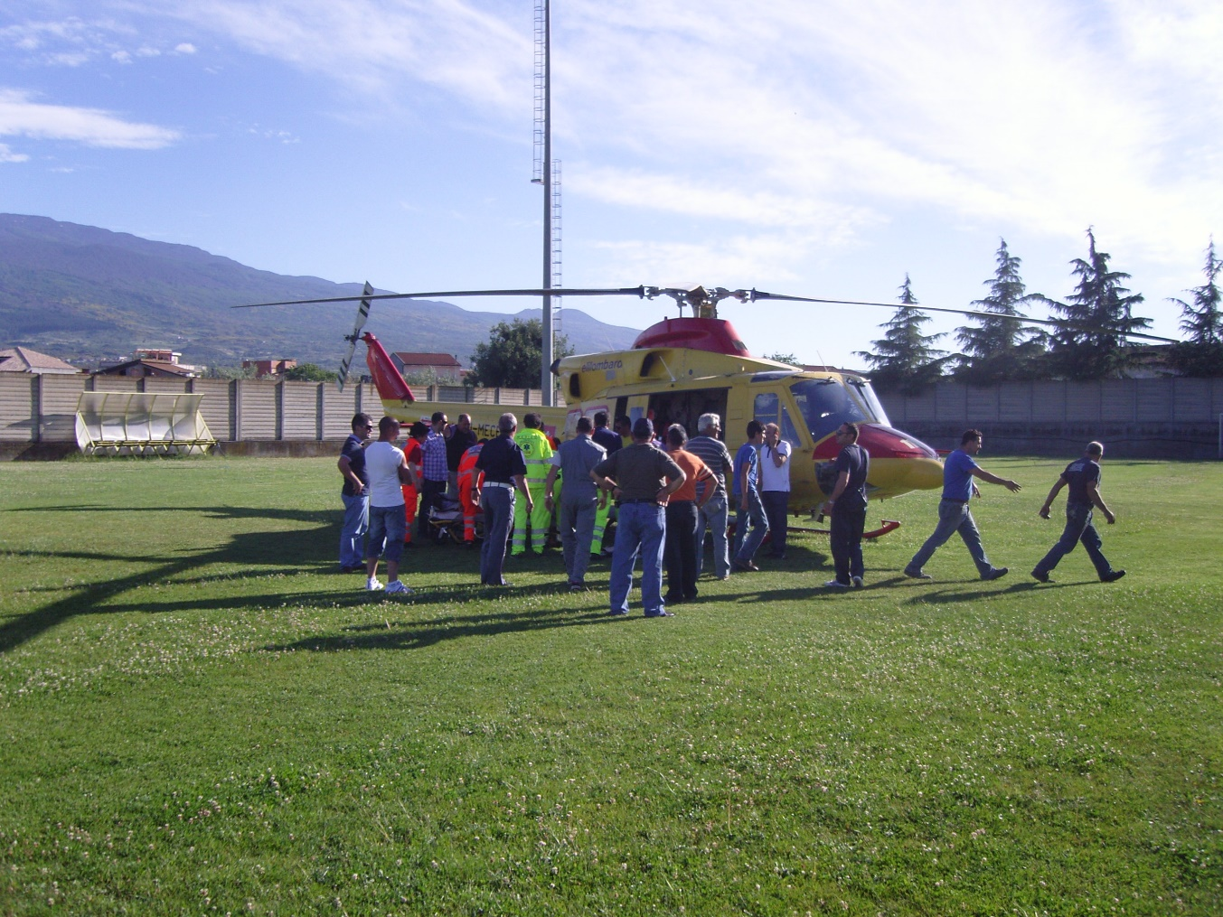
Picture 19 - Personnel not involved should be kept away from the helicopter

If on a road, the traffic can slowly start moving. Provisions must be taken in order to have personnel controlling the traffic and keep it well away from the helicopter. Vehicles shall not run under the rotor disc.

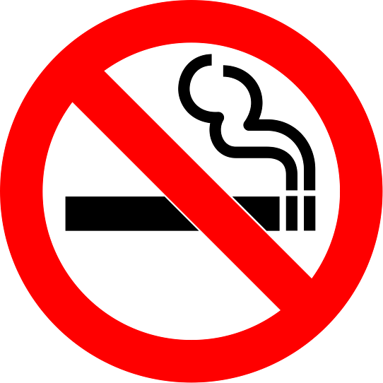

Smoking is prohibited at any time in proximity of the helicopter, even with engines off.
The helicopter has several high flammable substances, like fuel, oil, oxygen, etc.

WHAT PILOTS SEE FROM THE AIR
As an example, following is what a pilot, coming for landing, could see when arriving in an accident site. There is a list of peculiarities that is evident from the pilot perspective but that are not always understood by the on-site emergency personnel.
The final decision about if and where to land is a pilot responsibility.
The following example has some elements that preclude the landing, others that will allow the landing, but they will increase the risk. However, it is requested to the on-site personnel avoid at least most of the hazardous elements and report the on-site hazards to the emergency centre, in order to achieve the expeditious and safe helicopter operation.

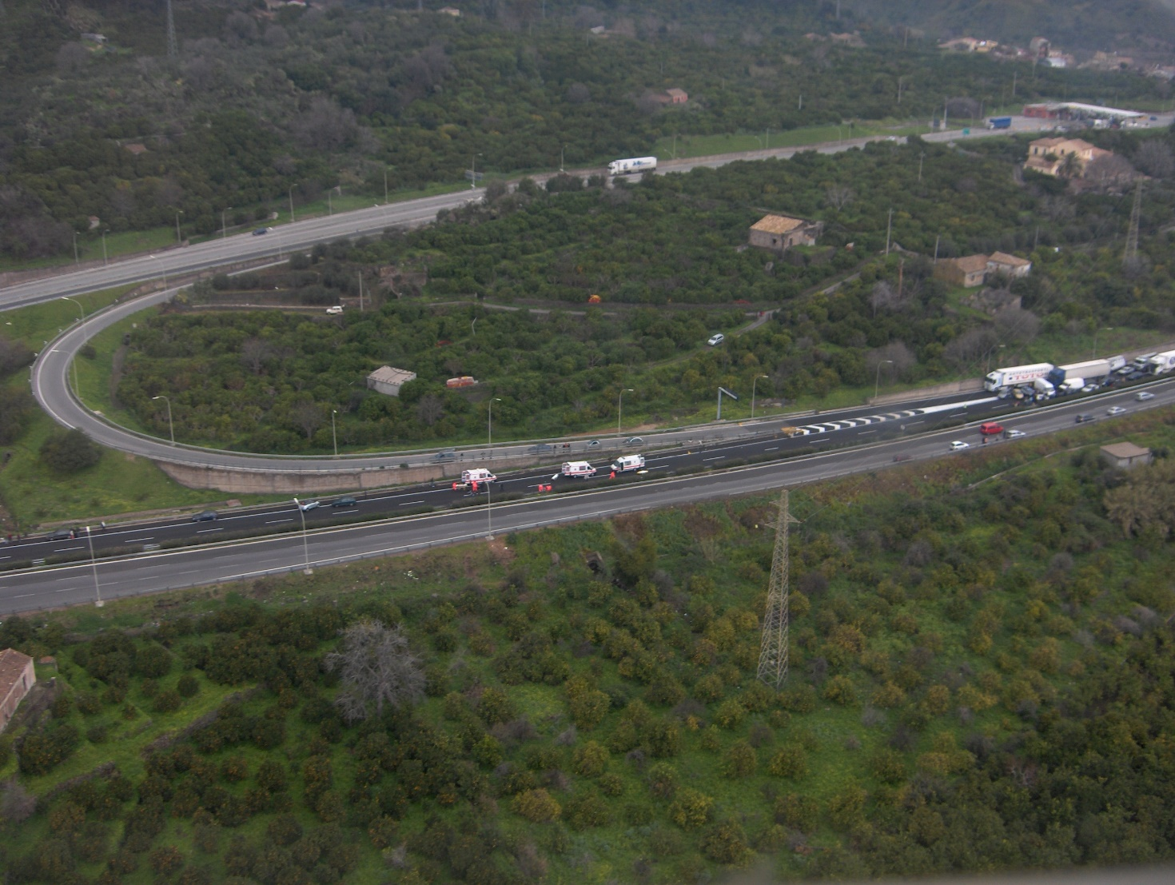

2

1

- There is a big power line crossing the highway, reducing the approach paths available and the take-off path afterward.
- Street lights will further reduce the approach and take-off paths and will narrow it. The most probable path will overfly the ambulances, the emergency personnel and the patients, exposing them to the rotor downwash.
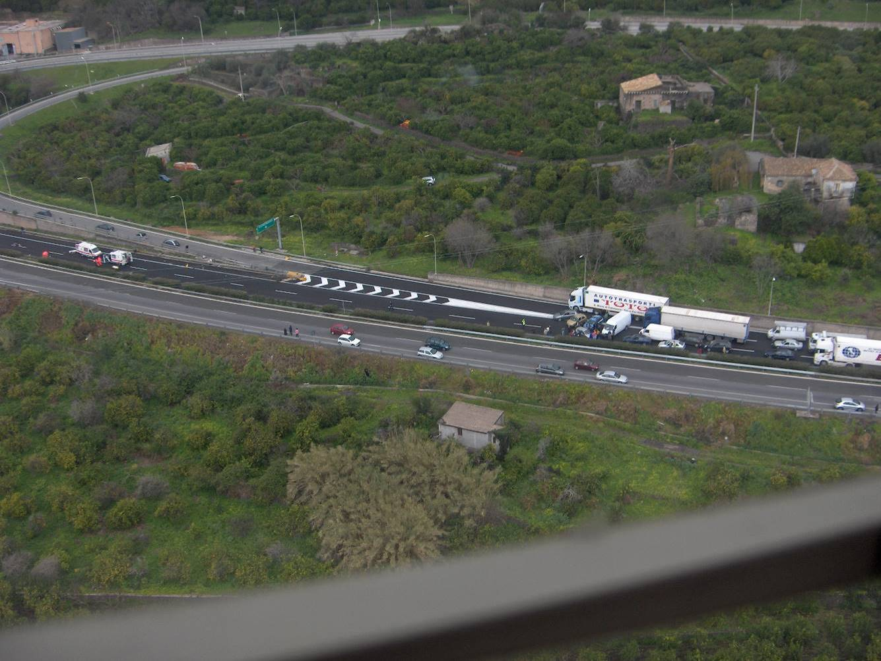

6

7

3

1

4

5

- Most suitable landing site.
- Ambulances and paramedic personnel.
The ambulances have the back and some front doors wide open.
The wheeled stretchers are standing free on the road. These can move due to the rotor downwash.
Stretchers have free sheets on top. These can be raised and sucked by the rotor.
- There are some persons not involved in the emergency operations close to the landing site.
- There are traffic signs close to the landing site.
- The traffic in the opposite way of the highway has not been stopped.

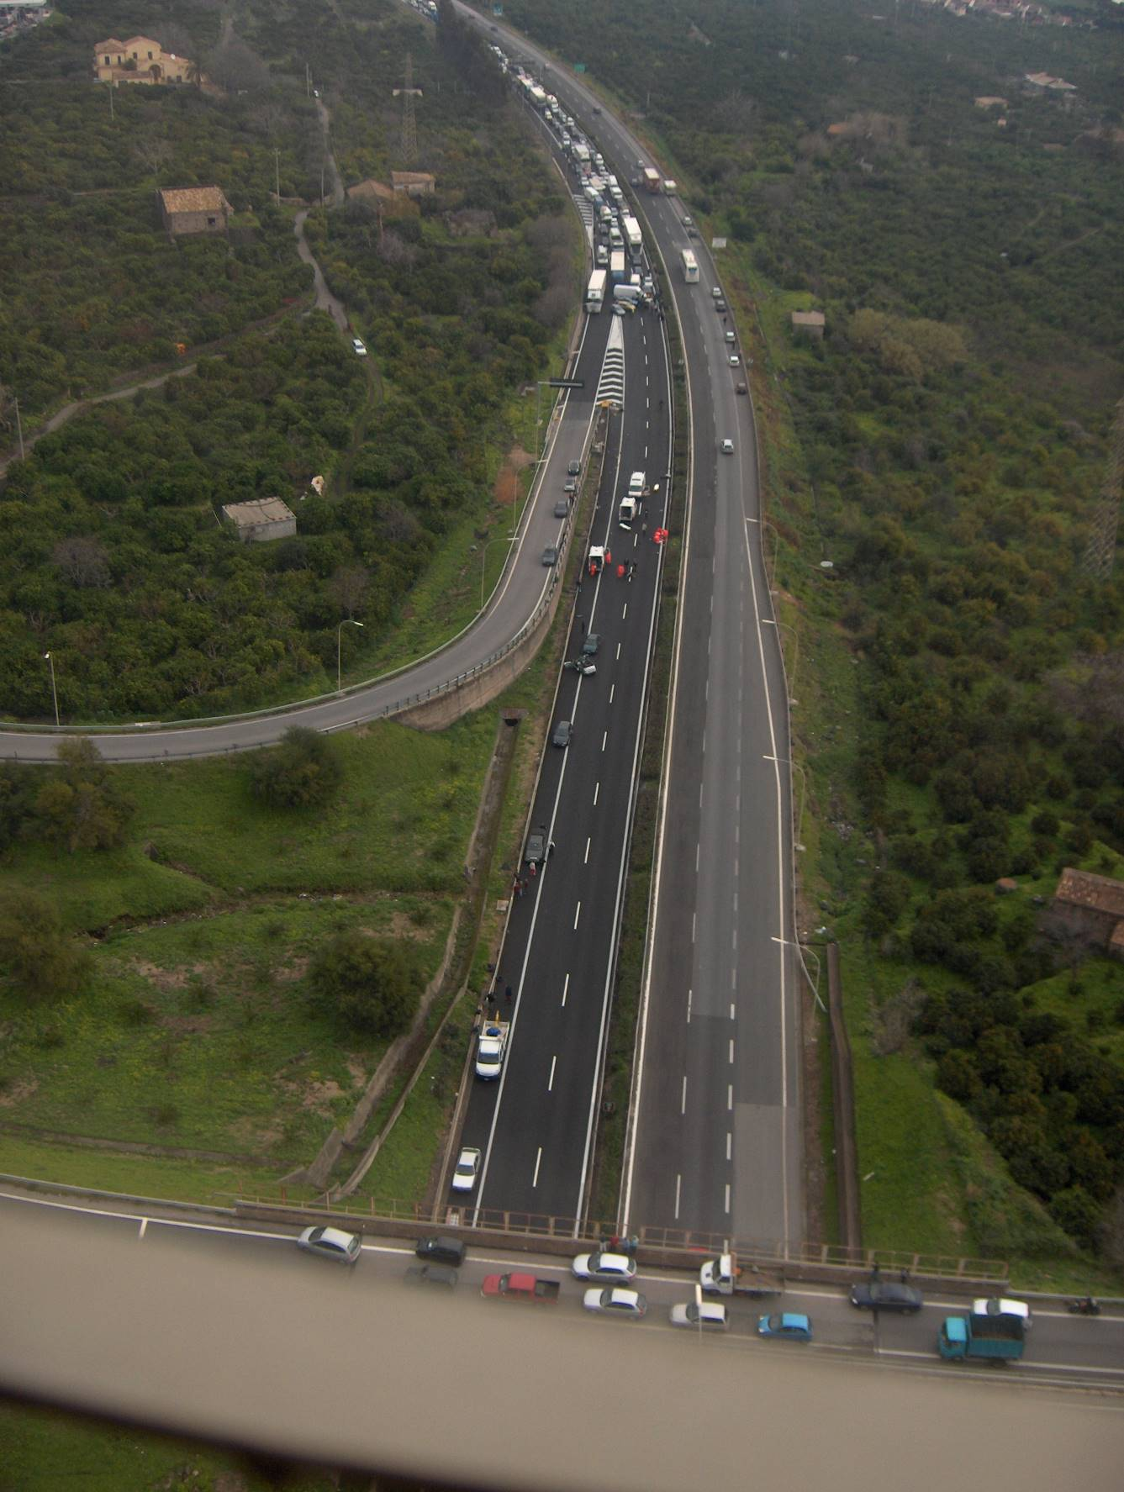

9

8

- This alternate landing site cannot be used because the traffic has not been stopped. Moreover, it could be difficult for the paramedics to bring the patient over the bushes that separate the two carriageways.
- These alternate landing sites are not usable because of a slope, covered with bushes or too close to trees or obstacles.

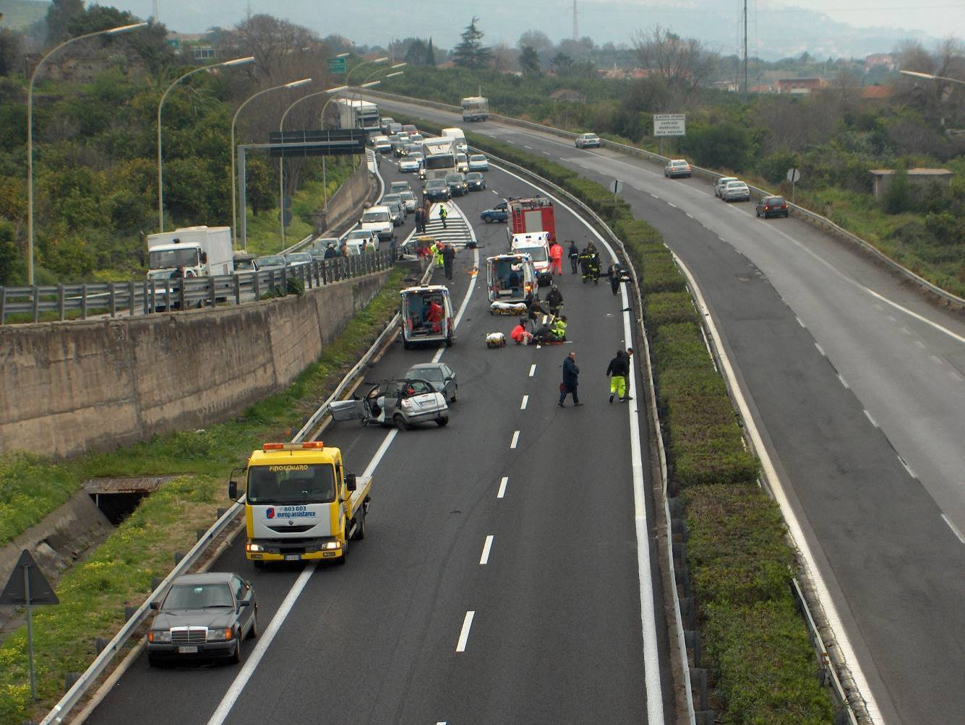

Would you have been able to find all these elements?

THE R.O.M.A. CHECKLIST (next page)

HELICOPTER MISSION REQUEST CHECKLIST - R.O.M.A.
R | Request – Type of mission – Specify position
Type of mission
- Emergency Medical Service? [ ]
- Transport of personnel (number? specific equipment? destination?) [ ]
- Transport of goods (type? Dangerous? Weight? Dimension? packaging?) [ ]
- Firefighting (where? other aircraft/vehicles/personnel in the area?) [ ]
- Rescue (helicopter fitted with winch? is it required?) [ ]
Position
County: _________________________ Town, road: ________________________________
GPS coordinates (verify lat/long units):
Degrees, Minutes, Seconds N ____° ____’ ____” E ____° ____’ ____”
Degrees, Minutes, fraction of Minutes N ____° ____.____’ E ____° ____.____’
O | Obstacles – Verify obstacles in the landing area
Type of obstacle  Power lines, pylons, antennas  Funicular, lifts, cables  Drones, other flying objects  Animals, birds (e.g. seagulls) |  |  | Existence  [ ] no [ ] yes  [ ] no [ ] yes  [ ] no [ ] yes  [ ] no [ ] yes |  | Actions or Communications  Report distance from landing point  Warn the funicular/cable manager  No drones. Inform if other aircrafts. Radio freq.  Ward off birds. Pay attention to cows, horses, etc.
M | Meteorological – Report meteorological conditions
Visibility [ ] Good ( > 5 km) [ ] Marginal (2 – 5 km) [ ] Lower than 2 km
Wind [ ] Light [ ] Moderate [ ] Strong or gusting
Conditions [ ] Cloudy, overcast [ ] Rain [ ] Thundershower
Mountain tops [ ] Visible [ ] Not visible [ ] Patches of fog
Phenomena [ ] Hail [ ] Sand storm [ ] Tornado
A | Area – Prepare area - Safety
Type of area [ ] Prepared (helipad, heliport) [ ] Unprepared [ ] Elevated helipad
[ ] Road [ ] Highway (traffic stopped?)
[ ] Sports field (Guardian advised? Gates opened? Lights on?)
[ ] Ground, grass field [ ] Beach [ ] Mountain
[ ] Flooded [ ] Ski run or snowed surface
[ ] Other: _____________________________
Lights (at night) [ ] Not available [ ] Available: [ ] Removable lights [ ] Fixed spot lights
Surface [ ] Flat [ ] Sloped [ ] Hilly [ ] Mountain
Personnel in the area |  | Name |  | tel. number |  | Radio freq./Ch. | Band
Firefighters
Medical
Police
Other – Supplementary information
Planned stops? [ ] no [ ] yes Where? ________________
Persons to be embarked? No.: ________ Total weight: _______ Where? ________________
Passengers tel. No. (at least one): ______________________________________________________
Goods: Type: _______ Total weight: _______ Dimensions: _____________
SAFETY RULES WITH HELICOPTERS

- Normally, take-off and landing will be performed into the wind
- At night never point lights toward the pilot. Do not use cameras with flash
- NEVER approach from or walk toward the back of the helicopter: tail rotors kill!
- If you see the helicopter flashing lights ON, walk away and well clear from the helicopter: engines are going to be started and rotors will start moving
- DO NOT APPROACH OR LEAVE THE HELICOTER WHILE THE BLADES ARE TURNING, unless authorised by the pilot
- Approach or leave the helicopter from sides only. Do not raise your arms or anything above your head. Bend down when passing below the blades: these can bend very low
- Maintain visual contact with the pilot
- Embark and disembark one at a time and ALWAYS after authorisation and under supervision of the crew
- Let the helicopter crew come to you
- Don’t run or smoke within 25 m (75 feet) of the helicopter
- Don’t allow any vehicles within 25 m (75 feet of the helicopter). Keep them braked and still during helicopter operations
- Consider crowd and traffic control around the landing zone
- Keep yourself 50 m (150 feet) away from taking off and landing helicopters
- Secure any loose clothing or equipment (ball caps, sheets, plastic/light bags, umbrellas, car doors, loose papers, traffic signs, moped/bikes). The rotor downwash could be pretty strong.
- Pay attention to any animal in the vicinity. Try to ward them off.
- Keep the landing zone free of debris
- Protect yourself and the personnel from the rotor wash winds (wear glasses, helmets, ear muffs)
- Do not use the aircraft for a handhold
- Make sure there are no prohibited items on the passengers (flammable/exploding material, pressurised gasses, etc.). Request to turn off any electronic and transmitting apparatus

LANDING AREA
Dimensions of the area (depends on aircraft type): | A 50 x 50 m square or 50 m diameter.
Obstacle distances: | 100 m from power lines  50 m from trees  50 m from houses
Preferred: | Flat surface – NO irregular surfaces
Dust, soil, light debris snow: | In case of sand: water the surface  In case of dry soil: water the surface  In case of fresh snow: compact the snow
Verify:  (Pay attention to and secure any object that could be raised or fall due to the rotor downwash) | Dust containers  Bags, tarpaulin, sheets  Nets, ski, umbrellas, sun shade  Bikes, caps, loose helmets  Paper sheets, documents, light backpack, cameras

HELICOPTER MISSION REQUEST CHECKLIST - R.O.M.A.
R | Request – Type of mission – Specify position
Type of mission
- Emergency Medical Service? [ ]
- Transport of personnel (number? specific equipment? destination?) [ ]
- Transport of goods (type? Dangerous? Weight? Dimension? packaging?) [ ]
- Firefighting (where? other aircraft/vehicles/personnel in the area?) [ ]
- Rescue (helicopter fitted with winch? is it required?) [ ]
Position
County: _________________________ Town, road: ________________________________
GPS coordinates (verify lat/long units):
Degrees, Minutes, Seconds N ____° ____’ ____” E ____° ____’ ____”
Degrees, Minutes, fraction of Minutes N ____° ____.____’ E ____° ____.____’
O | Obstacles – Verify obstacles in the landing area
Type of obstacle  Power lines, pylons, antennas  Funicular, lifts, cables  Drones, other flying objects  Animals, birds (e.g. seagulls) |  |  | Existence  [ ] no [ ] yes  [ ] no [ ] yes  [ ] no [ ] yes  [ ] no [ ] yes |  | Actions or Communications  Report distance from landing point  Warn the funicular/cable manager  No drones. Inform if other aircrafts. Radio freq.  Ward off birds. Pay attention to cows, horses, etc.
M | Meteorological – Report meteorological conditions
Visibility [ ] Good ( > 5 km) [ ] Marginal (2 – 5 km) [ ] Lower than 2 km
Wind [ ] Light [ ] Moderate [ ] Strong or gusting
Conditions [ ] Cloudy, overcast [ ] Rain [ ] Thundershower
Mountain tops [ ] Visible [ ] Not visible [ ] Patches of fog
Phenomena [ ] Hail [ ] Sand storm [ ] Tornado
A | Area – Prepare area - Safety
Type of area [ ] Prepared (helipad, heliport) [ ] Unprepared [ ] Elevated helipad
[ ] Road [ ] Highway (traffic stopped?)
[ ] Sports field (Guardian advised? Gates opened? Lights on?)
[ ] Ground, grass field [ ] Beach [ ] Mountain
[ ] Flooded [ ] Ski run or snowed surface
[ ] Other: _____________________________
Lights (at night) [ ] Not available [ ] Available: [ ] Removable lights [ ] Fixed spot lights
Surface [ ] Flat [ ] Sloped [ ] Hilly [ ] Mountain
Personnel in the area |  | Name |  | tel. number |  | Radio freq./Ch. | Band
Firefighters
Medical
Police
Other – Supplementary information
Planned stops? [ ] no [ ] yes Where? ________________
Persons to be embarked? No.: ________ Total weight: _______ Where? ________________
Passengers tel. No. (at least one): ______________________________________________________
Goods: Type: _______ Total weight: _______ Dimensions: _____________

